
FURTHER MATHEMATICS
TRIAL EXAMINATION 2
SOLUTIONS
2008

Section A

Core - solutions

Question 1

- The boxplot is negatively skewed.
(1 mark)

- The interquartile range is
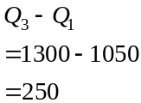
(1 mark)

- If a piece of data is less than
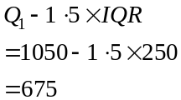
then it is an outlier.
Since , it is an outlier.
(1 mark)

Question 2

- Enter the data into your calculator.
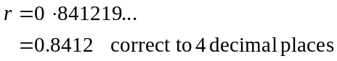
(1 mark)

- The coefficient of determination is given by
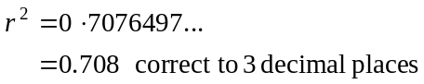.
(1 mark)

- Since 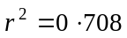, 71% (to the nearest whole percent) of the variation in weekly pay can be accounted for by the variation in age.
(1 mark)

- i. The equation of the least squares regression line is given by
(1 mark) correct numbers
(1 mark) correct equation

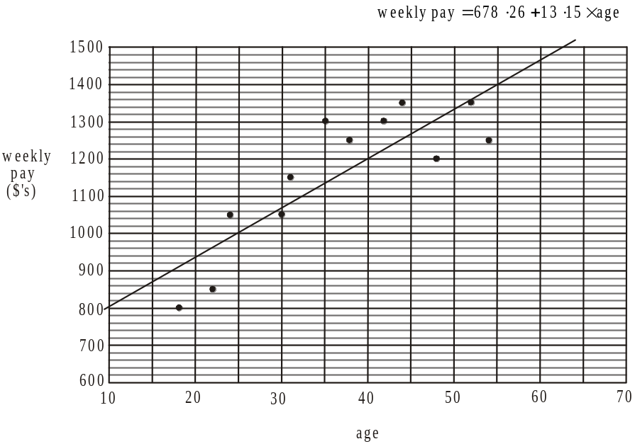

(1 mark)
- The actual weekly pay of the employee aged 54 is $1 250.
Using the least squares regression equation,
when age = 54,
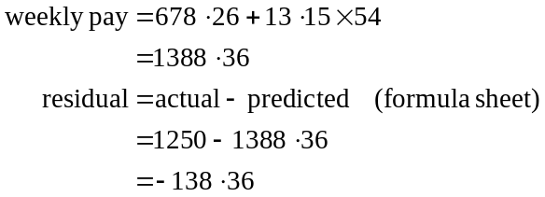
(1 mark)
- The residual plot shows a pattern; albeit rough, of an inverted parabola. This suggests that the relationship may not be linear. If there were a random collection of points on the residual plot we could assume there was a linear relationship.
(1 mark)

- A transformation that might be used to linearise the data would be the 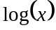 transformation or the transformation or the 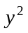 transformation.
(1 mark)
(only 1 needs to be mentioned)

Question 3

- The time series plot shows seasonal variation that is trending upwards.
(1 mark)

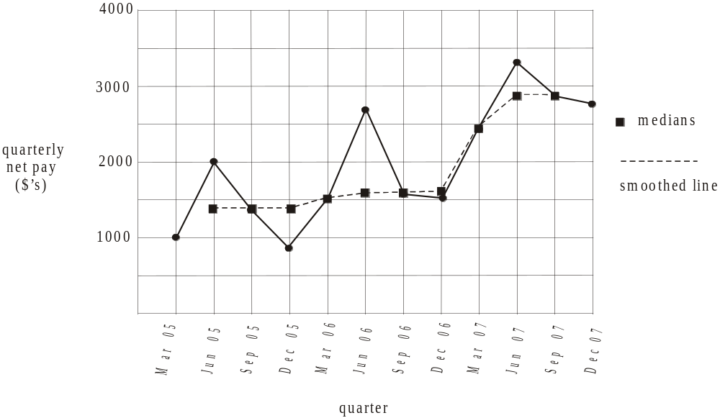

(1 mark) 5 correct points
(1 mark) 10 correct points
Total 15 marks

SECTION B

Module 1: Number patterns

Question 1

- At her third session Jane will do 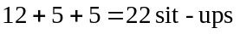.
(1 mark)

- Use a calculator to count up how many sessions she does to first complete more than fifty sit-ups.
It is at her 9th gym session.
(1 mark)

- 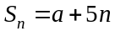
At session 1 Jane does 12 sit-ups.
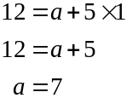

(Check: at session 2 Jane does 17 sit-ups
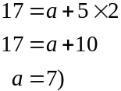
(1 mark)

- Use the formula in part c.
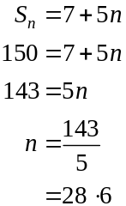

During Jane’s 29th session she will reach the limit.
At her 28th session she will do
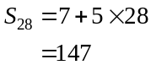
so during her 29th session she will reach 150 sit-ups.
(1 mark)

Question 2
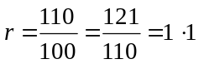

(1 mark)

- We have a geometric sequence so the equation will be of the form
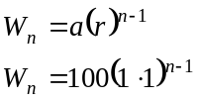
(1 mark)
since a represents the first term in the sequence.

- Method 1 – using a CAS calculator
Solve the equation 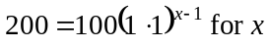.
So
So during his 9th gym session he will first lift 200kg.
(1 mark)
Method 2 – using a graphics calculator
Graph the equation 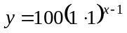
Look at the table of values and see the value of x where y first exceeds 200.
Now, when so during the 9th gym session he will first lift 200kg.
(1 mark)

- Total of weight lifted for sessions 1 to 9 is given by
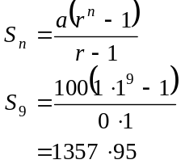
Total of weight lifted for sessions 1 to 15 is given by
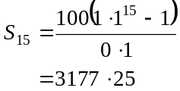
Now, .
The total of the weights lifted from the 10th to the 15th session inclusive is given by
1 819kg (to the nearest kg).
(1 mark) making reasonable attempt
at finding 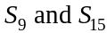
(1 mark) correct answer

Question 3

- 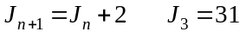
If 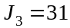 then
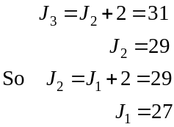
Jane spends 27 minutes at her first session.
(1 mark)

- The sequence described is arithmetic because there is a constant difference of 2 between each term.
(1 mark)

- We have an arithmetic sequence with .
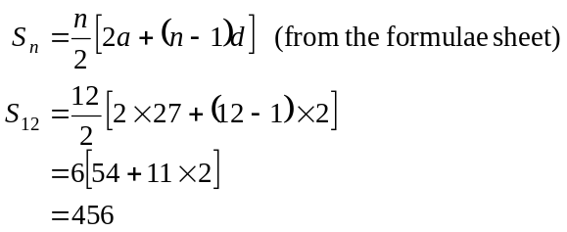
Jane spends a total of 456 minutes at her first 12 sessions.
(1 mark)

Question 4

- For session 1, Jane spends 27 minutes and Michael spends 20 minutes.
So Jane spends 7 minutes more than Michael.
(1 mark)

- From the graph, the first time that Michael spends more time at the gym during a session is during session number 14.
(1 mark)

- At session 20, the gap between the points is greatest and hence the difference in the time spent at the gym is the greatest.
(1 mark)
Total 15 marks

Module 2: Geometry and trigonometry

Question 1

- In we use Pythagoras.
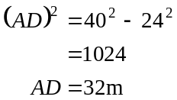
(1 mark)

- Since and are similar,
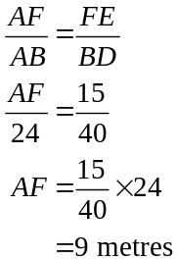
(1 mark)

- In , we have
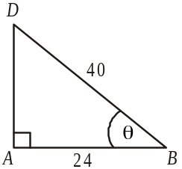
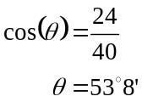
(1 mark)

- and are similar. Since the ratio of the sidelengths is 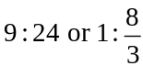 then the ratio of the areas will be
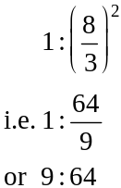
(1 mark)

Question 2
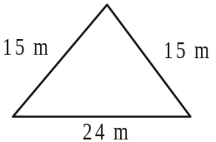
- The area of the triangular end of the triangular
prism can be found using Heron’s formula

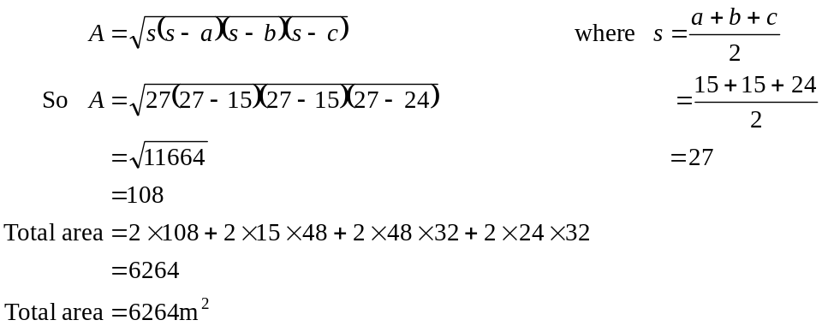
(1 mark)
(1 mark)

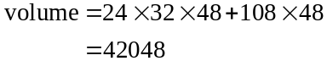
(from part a.)

volume of building is 42 048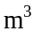
(1 mark)

- The model and the actual building are similar shapes.
The ratio of the sidelength of the model to the sidelength of the building is 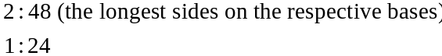
Therefore, the ratio of the volumes of the model to the building is 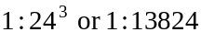.
(1 mark)

- Volume of scale model is 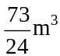.
So, volume of actual building
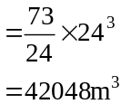
(from part c.)
(1 mark)
This confirms our answer found in part b.

Question 3
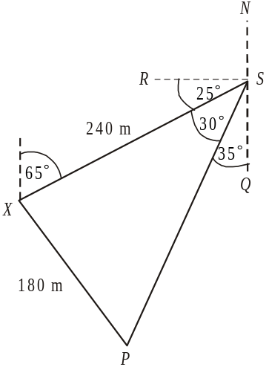

Since the bearing of P from S is 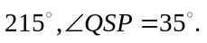 Also 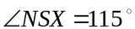 (cointerior angles add to give 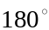) and so 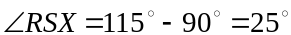.
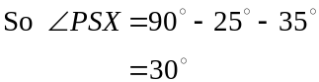
(1 mark)
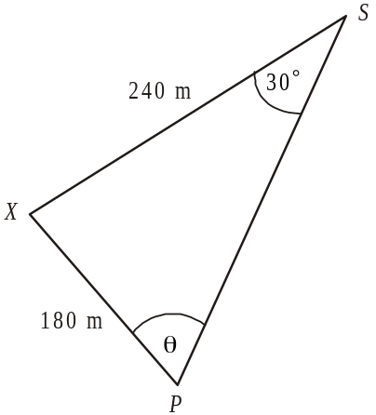

- In 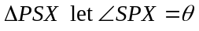.
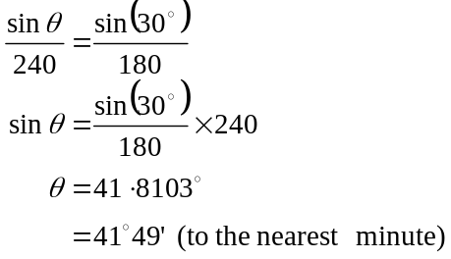

(1 mark)
- In . (1 mark)
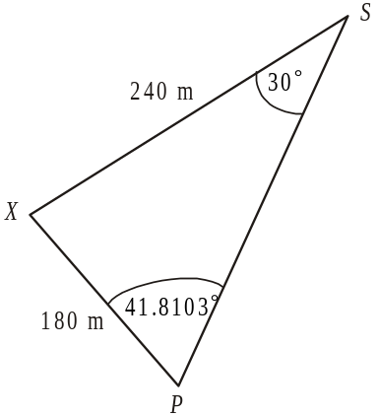
Note: don’t use the rounded value from
part b. and don’t round during a question.
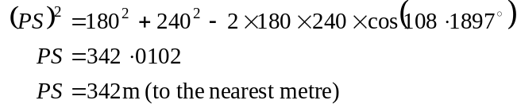

(1 mark)

- From part c. 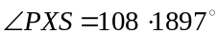 so the bearing of the post office from X is
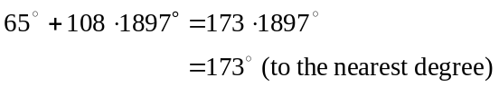
(1 mark)

- Method 1
Using the formula 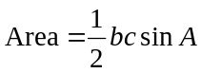
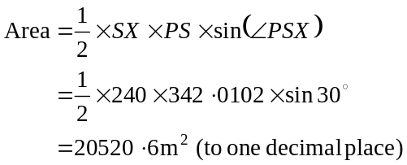
(using your answer from part c.
Note: don’t use your rounded answer)

(1 mark)

Method 2
Using the formula
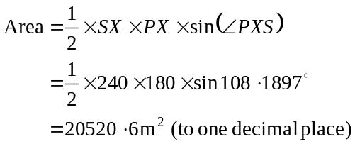
(from part c.)
(1 mark)

Method 3
Using the formula
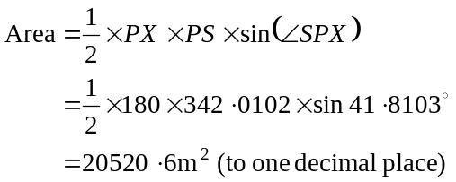
(from parts b. and c.)
(1 mark)
Method 4
Using Heron’s formula

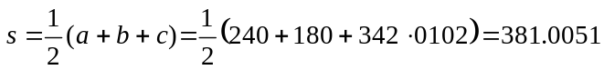

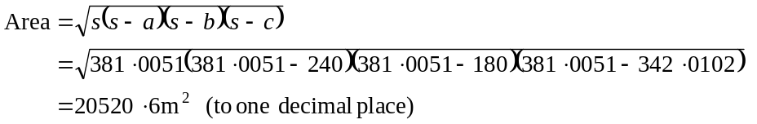
(1 mark)

Total 15 marks
Module 3: Graphs and relations.

Question 1

- At 1.30pm the temperature is 19C.
(1 mark)

- During the first hour the temperature rises most quickly.
(1 mark)

- i. The maximum temperature is 20C.
(1 mark)

- This occurs at 11.30am.
(1 mark)

Question 2

- 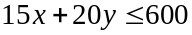
(1 mark)

- 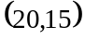
(1 mark)
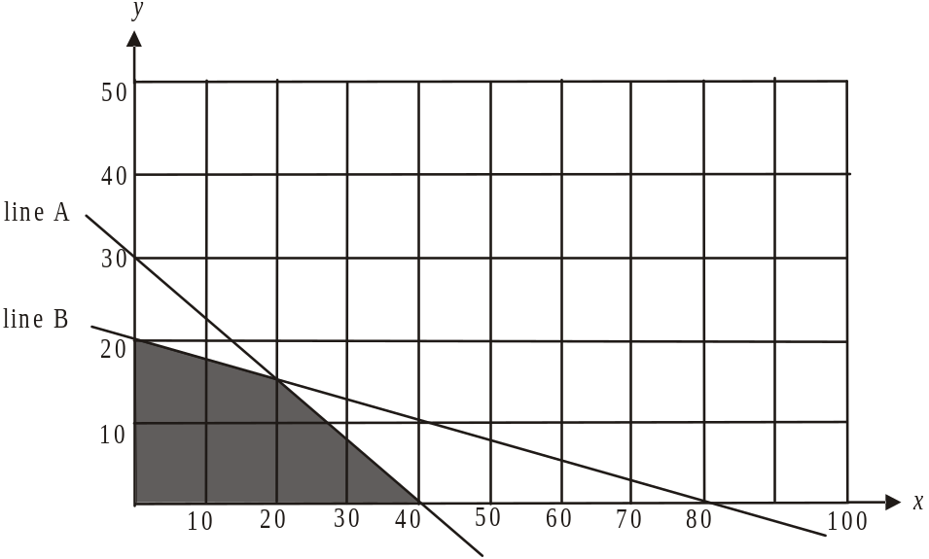

(1 mark)
- i. 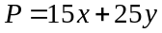
(1 mark)
  - At the corner points,
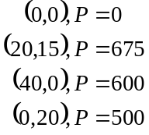
For a maximum profit there should be 20 male clients and 15 female clients.
(1 mark)

- The new inequality is 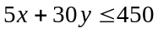.
(1 mark)
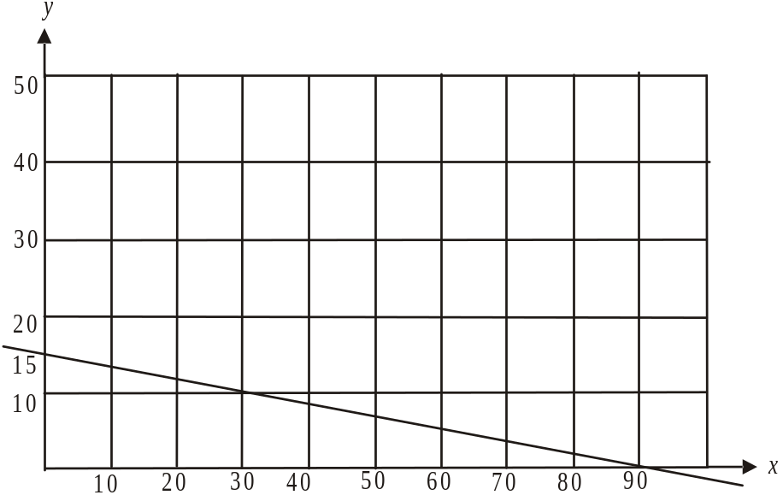

(1 mark)

Question 3
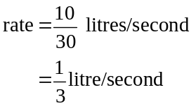

(1 mark)

- The conditioner is applied between .
It takes 90 seconds.
(1 mark)

- There is litres of water used.
(1 mark)

- The tap is on between , and then between and then between .
The total time is seconds.
(1 mark)
Total 15 marks

Module 4: Business-related mathematics.

Question 1
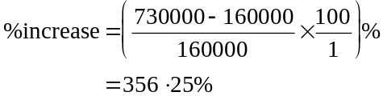

(1 mark)

- Marco made a profit of .
Assuming no costs were incurred, this was all profit so the capital gain was $570 000.
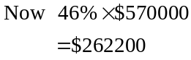
is the capital gains tax that Marco must pay.
(1 mark)

- Nick paid $730 000 for the property so he must pay
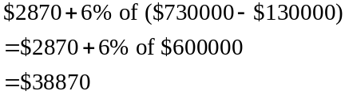
(1 mark)

Question 2

- 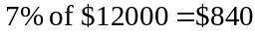
Marco will pay 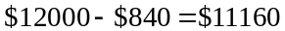
(1 mark)

- i. Marco will pay .
(1 mark)
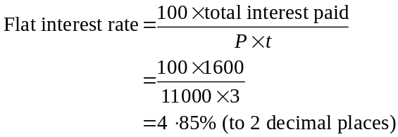

(Note: the deposit is deducted from the principal.)

(1 mark)

- Marco is charged interest for the second $6000.
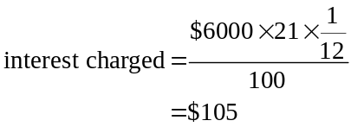

(1 mark)

Question 3

- i. 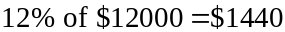.
The kitchen equipment depreciates by $1 440 each year.
(1 mark)
  - After 1 year it will be valued at 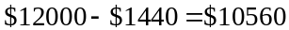.
After 2 years it will be valued at .
After 3 years it will be valued at .
After 4 years it will be valued at 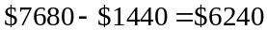.
After 5 years it will be valued at .
It will take 5 years.
(1 mark)

    - For reducing balance depreciation,
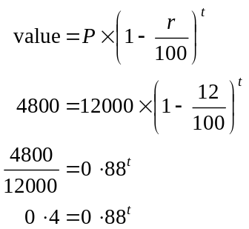
(1 mark)
Method 1 – trial and error
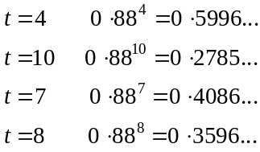
So during the eighth year the equipment would be valued at $4 800.
(1 mark)
Method 2 – using equation solver function on calculator
The equation to solve is
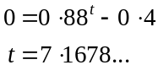
So during the eighth year (i.e. 7 years have elapsed and we are 0.1678 into the eighth year) the equipment would be valued at $4800.
(1 mark)
Question 4

- Using TVM solver, we have
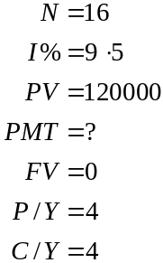
He makes quarterly payments of $9102.70.
(1 mark)

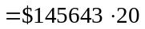

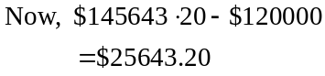
So Marco pays a total of $25643.20 in interest.
(1 mark)

- If Marco paid the loan off in 2 years his quarterly instalments would be found using TVM solver:
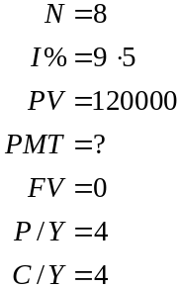
Quarterly instalments would be $16647.00. (1 mark)
Over 2 years he would pay in total 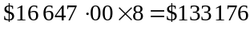.
This means he pays 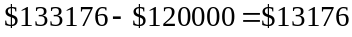 in interest.
So paying it off in 2 years rather than 4 saves Marco
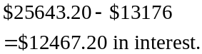
(1 mark)
Total 15 marks
Module 5: Networks and decision mathematics

Question 1

- The degree of vertex F is 5.
(1 mark)

- Some examples of a Hamiltonian circuit are
A G F E D C B A
A G E D C F B A
A B C D E F G A
Other routes are possible.
The route must start and finish at A and pass through each vertex just once.
(1 mark)

- An Euler circuit does not exist for this graph because all the vertices do not have an even degree.
(1 mark)

- Using trial and error, the shortest route from A to D is A G E D.
(1 mark)

Question 2

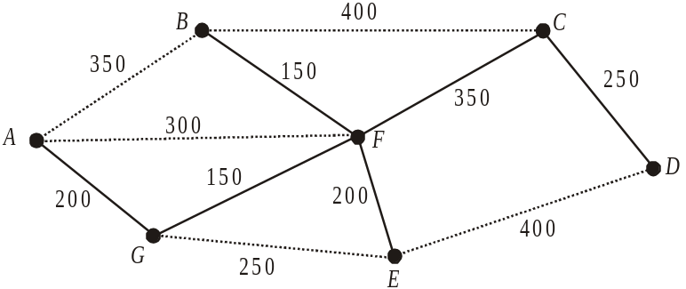

(1 mark)

- Total length of paths to be resurfaced is .
(1 mark)

Question 3

- The capacity of the cut shown is 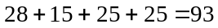 litres/sec.
Note that since the edge with capacity 26 is flowing in the opposite direction (low to high) it is not counted.
(1 mark)

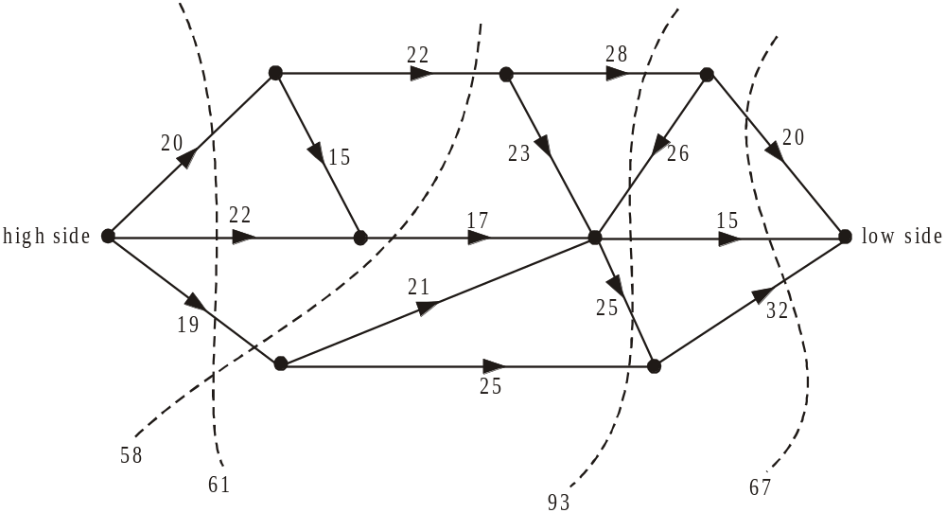

The minimum cut is 58 so the maximum capacity is 58 litres/sec.

(1 mark)
Question 4

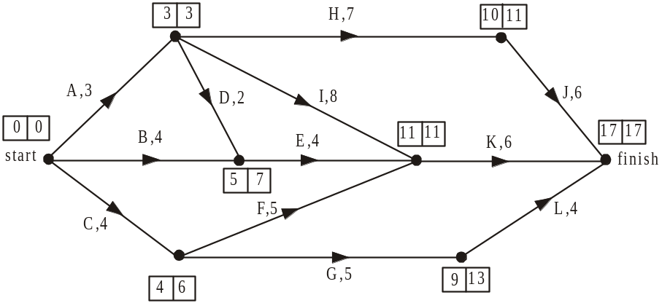

The earliest start times are indicated in the left hand box for each activity and the latest start times are indicated in the right hand box. The earliest start time for activity K is 11 weeks.
(1 mark)
- The latest start time for activity D is 7 – 2 = 5 weeks.
(1 mark)

- The sum of the duration of the activities along the critical paths is 17 weeks, so the minimum time is 17 weeks.
(1 mark)

- The float time for activity F is .
(1 mark)
- The critical path is A ,I and K.
Since A and I are on the critical path, individually, they will reduce the overall completion time.
(1 mark)

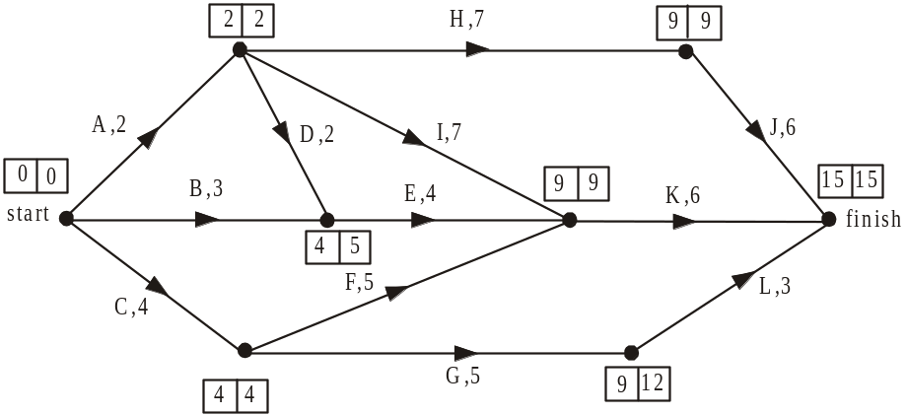

The minimum completion time is now 15 weeks.
(1 mark)

- Those activities that are now critical to the project being completed by this reduced time are A, H, J, I, K, C and F.
(1 mark)

Total 15 marks
Module 6: Matrices

Question 1
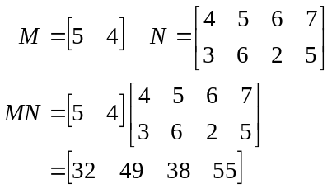
- i.

(1 mark)

- N is a matrix
M is a matrix
Since the number of columns of N (4 columns) does not equal the number of rows of M (1 row), NM does not exist.
(1 mark)

- P is a matrix
N is a matrix
The order of NP will be .
(1 mark)
- Using the matrix MN which gives the maximum number of pages for the two assessment tasks for the two subjects in the four homerooms, we see that for 12C the number is 38.
(1 mark)
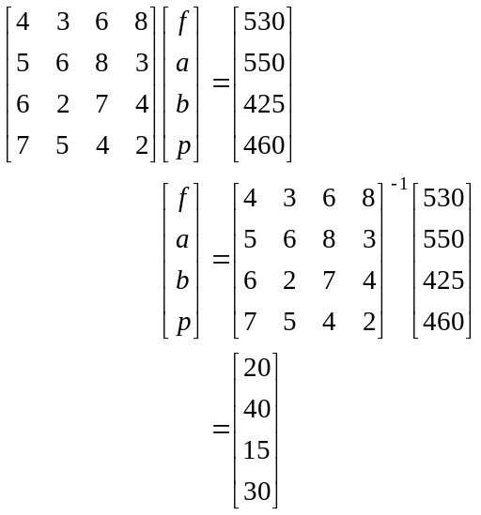

So 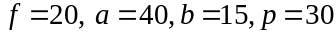
(1 mark) for attempting to find or use the inverse matrix
(1 mark) for the correct answer

Question 2

- There were people.
(1 mark)

- Since the columns of a transition matrix must add to give 1, .
(1 mark)

- From the transition matrix we see that 0.7 or 70% of people studying this year are predicted to be working next year.
(1 mark)

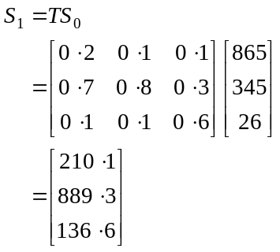
- i.

(1 mark)

- 0.3 or 30% of people move from other activities to full-time work each year.
In the first year that number is .
So 8 (to the nearest whole number) moved to full-time work.
(1 mark)

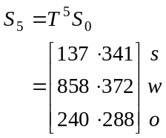

To the nearest whole number there are expected to be 858 people working after five years.
(1 mark)

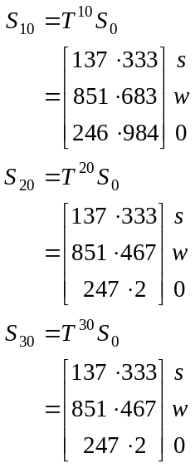
A steady state has been reached.
(1 mark)

- 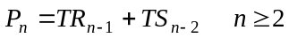

When , we have
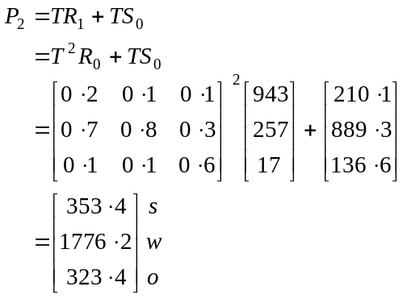
(Note 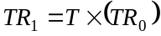
from part d. i.
(1 mark)

- There are 1776 people from both research projects who are in full time work two years after the first of the research projects began.
(Note that this is at the end of the first year for the second research project.)
(1 mark)
Total 15 marks

